Northern Garrett High School
Research Handbook
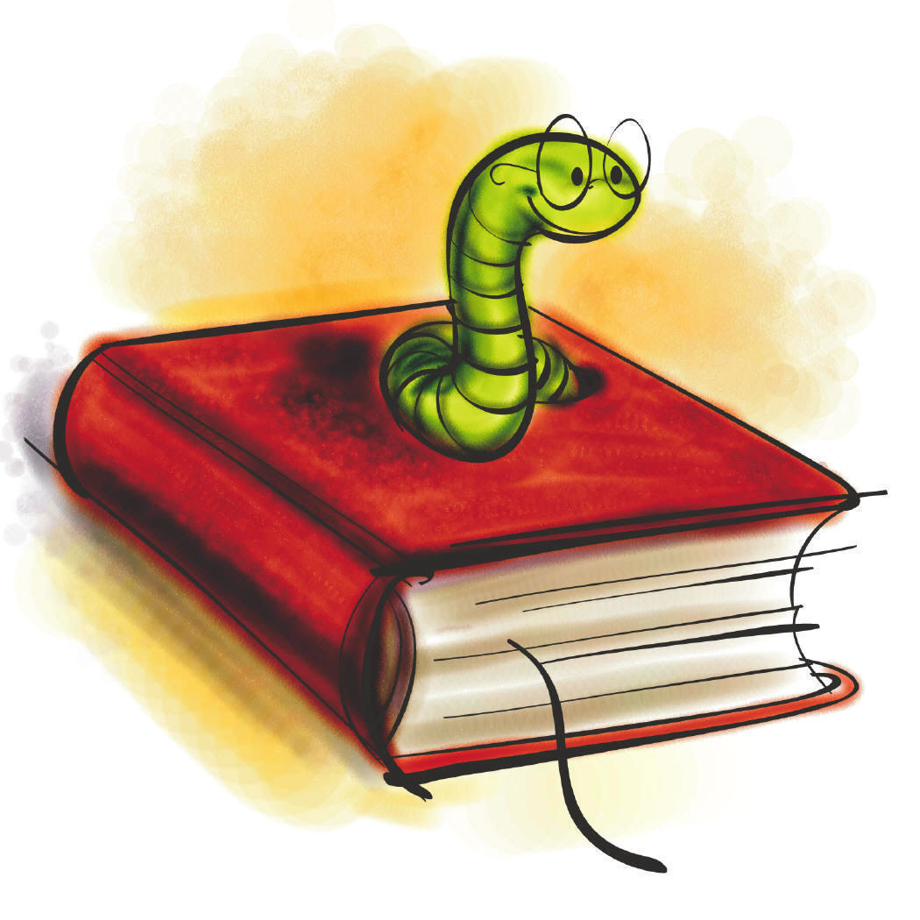Samantha Roller
Teacher Librarian
Northern Garrett High School Research Handbook
Table of Contents

Library Organization…………………………………….. 3

BIG 6 Process………………………………………………… 6

Topic Selection……………………………………………… 10

Available Online Resources………………………… 13

Evaluating Online Resources……………………… 16 - 17

Available Print/Periodical Resources……… 18

The Dewey Decimal System…………………….. 23

Evaluating Print Resources………………………. 25

Plagiarism…………………………………………………….. 26

Citing Sources…………………………………………….. 33

My Resources……………………………………………… 41


Welcome!
To the Northern Garrett High School Library!

Introduction: If you have a research project, don’t panic! The best place to start your research is right in your school. Your school’s Media Center has a ton of resources to use and loads of suggestions for out of school resources.
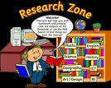
Your section selections:

Biography: This section includes works that are accounts of a person’s life; they can appear in written or video form. These resources will be found on the shelves in Dewey Decimal order, under the heading
NON-FICTION.

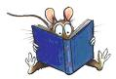
Fiction: This section includes written works that are based on creativity and the authors’ imagination. These books can be found on the shelves in front of the library, in Dewey Decimal order, under the heading FICTION.

Magazines: This section includes publications that are issued daily, weekly, bi-weekly, monthly, bi-monthly, annually or bi-annually. They can contain articles that are fact-based or those that are exaggerated. We are currently working on adding different publications, so stay tuned!

Newspapers: This section includes publications that are issued daily or weekly, which contain current news, events, editorials, feature articles and advertising. These sources will also be added as soon as possible!

Non-fiction: This section includes writing that deals with facts or real events. These books will be found on the shelves in Dewey Decimal order, under the label NON-FICTION in the Media Center.



Reference: This section includes resources such as dictionaries, encyclopedias, almanacs, and atlases. These books will provide you with factual information in a snapshot style. These resources can be found on the shelves in Dewey Decimal order, under the heading REFERENCE.

Online Resources: This section includes everything that the Northern Garrett computers have access to. All of the computers in our Media Center have access to these resources. If you need help in any way just ask.


The BIG 6

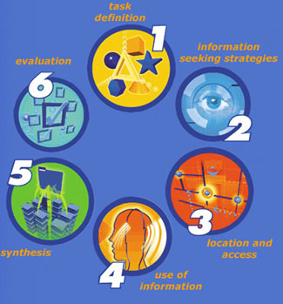

(Pssst…don’t worry it’s just a research project)
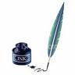 What is the “BIG 6”?
The BIG 6 is a name for a method of research. The “BIG 6” represents the six steps that will help you through the research process. It will ultimately help you problem solve in a very orderly way.

Here’s how it works:

The six steps are:
- Task Definition
- Information Seeking Strategies
- Location and Access
- Use of Information
- Synthesis
- Evaluation

What do these steps mean?
1. Task Definition:
During this step, you will decide what your problem/question is that you wish to research.
Sometimes you will be expected to come up with one on your own, other times you will be given a specific topic.


2. Information Seeking Strategies:
During this step, you will decide what resources you will need in order to solve your problem, or answer your question. Resources can range from books, almanacs, encyclopedias, dictionaries, newspapers, magazines, personal interviews or the Internet. It is also important to starting thinking about where you can find these resources.

3. Locations and Access:
During this step, you will figure out where you need to go in order to find your resources. Examples of places that have several different types or sources are: The Public Library, the School Media Center, a bookstore, etc. Remember it is important to narrow down your locations so that time is spent wisely.

4. Use of Information:
During this step, you will be organizing your information so that it is easy for you to access later. Taking notes is an essential part of any research project. That way you won’t have to go back to the exact source every time you need specific information.


5. Synthesis:
During this step, you will begin to shape/mold the information that you have found into a project. What will this project look like? Most likely you will be given a list of types of projects and expectations for each. The goal will be to choose the one that most suites you and your topic.

6. Evaluation:
During this step, you will evaluate your own research process. Have you completed all the steps? (Specifically the first 5) Would you change anything about your process? Was there anything you would do the same? Which step was the most helpful? Which step was the least helpful? What are some ways that you can make the BIG 6 a smoother process for next time?

What?!
Pick a Topic?

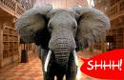

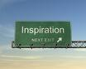
Selecting a Topic

How?
You should always pick a topic that:
- is either important or interesting to you
- answers the question or solves the problem given to you in class
- has enough solid information to research (meaning the topic is not too broad or too narrow to research)
- is challenging and new
If you aren’t interested in your topic even a little bit, your project will be an uphill battle.

Example:
- Let’s say you’re given a topic by a teacher. Let’s say that topic is to choose a famous person who has been influential to you. Now let’s break down the steps of selecting your personalized topic.

- Your general topic is: Do a research project about a famous person who has been influential to you.

- A more specific topic would be: Choosing what type of famous person you will research – Artist, Musician/Band, Poet, Author, Actor, Actress, Political Leader, Newscaster, etc.

- An even more specific topic would be: Choosing Musician/Band as the focus and then picking you favorite type of music – Rock and Roll, Alternative, Punk, Classical, New Age, Ethnic, Opera etc.

- The most specific topic would be: Choosing Rock and Roll and then deciding to go with a single artist or a band – U2, Aerosmith, Pearl Jam, Muse etc.

Now you are on your way! If this process is still confusing never be afraid to ask questions!

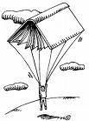

Online Resources



Available Online Resources

GCPS Online Subscription Databases
*Please note that each Login ID and Password are case sensitive.
- CultureGrams - Concise, reliable, and up-to date country reports on 182 world cultures.
  - Home Login ID: garretthome
  - Home Password: garretthome
- SIRS Knowledge Source - Thousands of full-text articles from domestic and international sources exploring social, scientific, health, historic, business, economic, political, and global issues.
  - Login ID: GCPSS
  - Password: TechCat
- World Book Online - This is the online version of this popular encyclopedia.
  - User ID: gcpss
  - Password: gcwbol

Evaluation of Online Resources

One of the many items we have to think about when we use online resources is whether or not the information is valid (reliable) and current (up to date). There are even sources out there that we may be tempted to use because they are easy to access, although their information may not be entirely dependable. If you aren’t sure about a particular site, here’s an easy checklist to follow to make sure you’re on the right track. You may pick up a hard copy of the chart at the circulation desk. Here are the questions on the chart:
Site Title:_________________________________________
Subject:__________________________________________
URL or Web Address:________________________________
Purpose for using this site:____________________________
Write yes, no, or briefly explain, to the following questions:
- Was the site easy to get to?
- Did the site appear quickly and load properly?
- Was the site relevant for what you were researching?
- Was the site easy to navigate?
- Was the author of the site identified?
- Was the publisher of the site identified?
- Could you find reliable information about the author and the publisher of the site?
- Is there a way to find out more about the site itself?
- Could you get in contact with the creators of the site?
10. Are there a lot of spelling and grammatical errors on the site?
11. Does the site provide when it was last updated?
12. Does the site clearly explain its purpose?
13. Is there enough information on the site related to your topic?
14. Is that information organized well?
15. Does the site provide links to other sites related to your topic?
16. Are the links clearly visible on the site?
17. Do the links work?
18. Was the site useful?
19. Did accuracy differ based on what type of site you visited? (examples: .com, .org, .edu etc.)

20. How did you feel overall about the website(s) you visited?

Print Resources
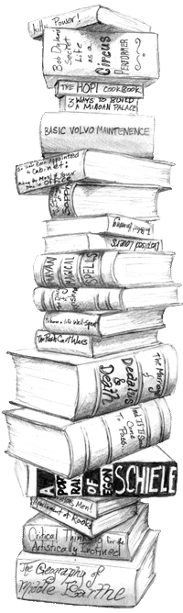
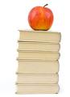 Available Print Resources

Encyclopedias: An encyclopedia is a reference work, usually consisting of many volumes, that contains factual articles on subjects in every field of knowledge. Typically they are organized alphabetically. For example, BBMS has the encyclopedia Britannica and World Book.

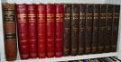

Dictionaries: A dictionary is a reference book that contains an alphabetical list of words with their meanings, parts of speech and other information.

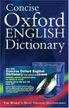

Directories: A directory is an alphabetical list of names and addresses.
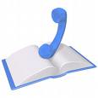

Biographies: A biography is a reference work that tells about important facts and events of someone’s life.

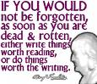

Geographic Resources: Geographic Resources have to do with the exploration of places via the following:

Atlas: An atlas is a collection of maps in book form. They can be useful for travel purposes or to view the topography (the shape of land) of the Earth.
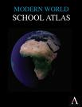
Almanacs: An almanac is a yearly-published reference book composed of various lists, tables, and brief articles relating to a topic or many general topics.

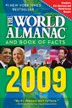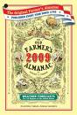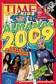

Yearbooks: A yearbook is a record to remember the past year of school.
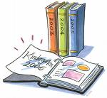
Handbooks: A handbook is a concise reference providing specific information about a subject or location. 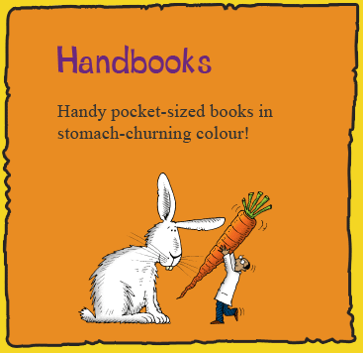 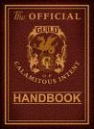
The Dewey Decimal System

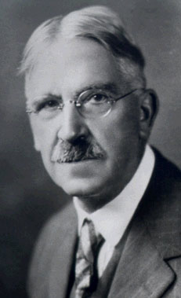

Dewey who?

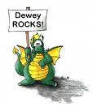 How to find what you need

The Dewey Decimal System is a numerical method of categorizing books in a library by subject matter. The following chart will help you understand how the Media Center’s books and materials are categorized on the shelves.
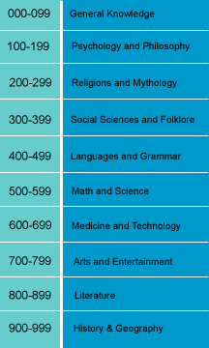
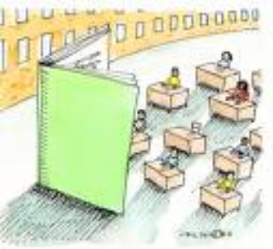 Evaluation of Print Resources

Answer the following questions to make sure that you are working with the best resources available. You may get a printed copy of the following questions at the circulation desk.

1. Is the layout easy to read and navigate?

2. Is the font big enough and in a legible color in contrast to the background?

3. Is the information appropriate for your research?

4. Will the information help you answer the questions you have about your topic?

5. Is the information current?

6. Is the information valid?

7. Are there enough details to support your research?

8. How comfortable was it for you to use this resource?



Plagiar – what?

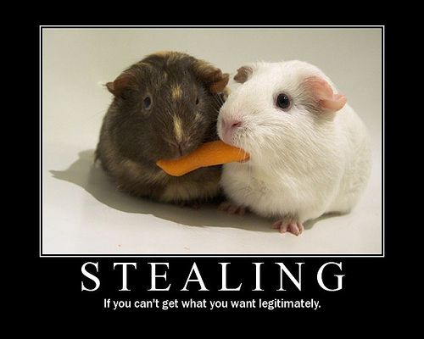

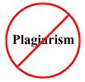
The Proper Use of Information

What is Plagiarism?
- Plagiarism is when a student takes someone else’s work and uses or claims it as their own.

Examples
- A student ‘borrows’ specific sentences from a textbook or any other resource and does not cite where they got it.
- copying and pasting from the Internet and posting somewhere else without proper citation
- putting your name on another person's essay or project
- copying exact wording from another person's text
- using another person's photo, diagram, sounds, or ideas without proper citation
- purchasing another person's text and using it as your own
- presenting ideas in the same format and order as your research source


How can teachers tell when you have plagiarized?
- if your writing is similar or exactly like another classmates
- if a project or paper doesn’t seem like a particular student’s work
- if a teacher finds direct quotes that have not been cited
- if a teacher checks it against one of the many online resources that provides projects or papers for money

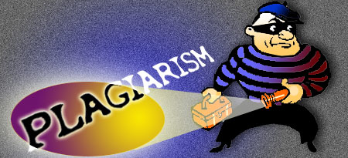
Being a word bandit is not okay.

What are the consequences if you get caught?

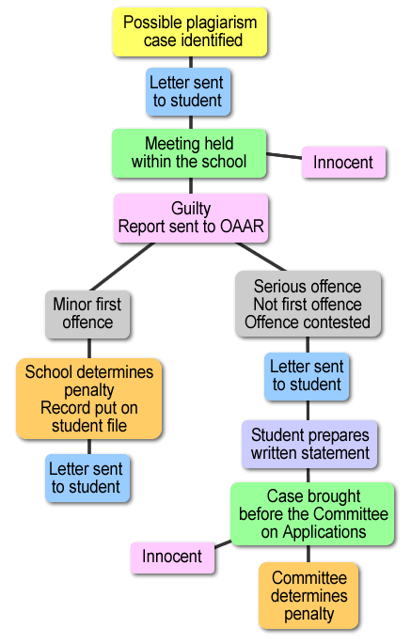
*OAAR = Office of Academic Appeals and Regulations

- Consequences are determined on a case-by-case basis.
- In middle school the minimum penalty for plagiarism is the student receiving an ‘E’ in the course.
- The maximum penalty for plagiarism is the student being expelled.

Ways to avoid plagiarism
Here’s a checklist:
- Did I make a list of all the books, articles, websites, and other sources I used?
- Did I keep track of which information came from which sources?
- When I used sentences just as they were in the source, did I always put quotation marks around them?
- When I summarized ideas in my own words, did I remember to give credit to the original source?
- Did I ask my teacher if I was unsure of how to list a source or whether to list it?

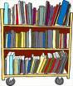
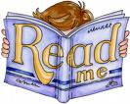
An Example of Plagiarism

The Original Material

Somewhere, many of us got the idea that simplicity in writing is a vice- that the long word is better than the short word, that the complex phrase is superior to the simple one. The misconception is that to write simply is to be simple minded. (Ballenger, Bruce. The Curious Researcher. New York, Allyn and Bacon, 1994. p.184.)

Type of Plagiarism

Direct Copying:

There is an idea out there that simplicity in writing is a vice-- that the long word is better than the short one, that the complex phrase is superior to the simple one. The misconception is that to write simply is to be simple minded.

Explanation:

Most of the first sentence and the entire second sentence are copied directly from Ballenger with no quotation marks and no citation.

Paraphrasing:

Many of us have the idea that simplicity in writing and speaking is a vice-that long words are better than short words, and that complex phrases are superior to simple ones. The idea is that writing simply shows means you are simple minded.

Explanation:

A few words are re-arranged and a few are substituted, but the idea and order of development is Ballenger's who is not cited.

Theft of an Idea:

Simplicity in writing is not a fault. The short word is better than the long word; the simple phrase is better than the more complex one. It is an error to think that one is simple minded because one writes simply.

Explanation:

The ideas are put in someone else's words, but they imply that they are the new author's rather than Ballenger's since Ballenger is not cited.

(The table concept comes from Auer, Nicole J. and Krupar, Ellen M. "Mouse Click Plagiarism: The Role of Technology in Plagiarism and the Librarian's Role in Combating It." Library Trends, Vol. 49, No. 3, Winter 2001, p.419. 415 -432.) They modified it with Permission of the author at http://www.english.vt.edu/%7EIDLE/plagiarism/plagiarism2.html

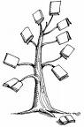
Citing Your Work Let’s You Live…



Northern Garrett High School 
MLA Citation Sheet
Top Ten Tips to Remember
1. Alphabetize your works cited list by the first word in each entry. (do not use A, An, or The)
2. Double space the entire list, both between and within entries. (unlike examples below)
3. One-inch margins.
4. The second line of the entry is indented ½” from the left margin.
5. One space after all periods, except periods for abbreviations. (i.e. or e.g.)
6. One space after all commas.
7. If information such as an author’s name is not given, skip it and continue to the next required information.
8. No underlining. Use italics where indicated.
9. Follow the format for each source as indicated below.
10. Every entry receives a Medium of Publication marker. (Print, Web, Video, etc.)

Book with one Author:
Author (Last Name, First Name). Title of Book. City of Publication: Publisher, Copyright Date. Medium of Publication.
Example:
Gravett, Christopher. The World of the Medieval Knight. New York: Harcourt, 1998. Print.

Book with Two authors:
Authors (Last Name, First Name, and First Name-Last Name). Title of Book. City of Publication: Publisher, Copyright Date. Medium of Publication.
Example:
McKissack, Patricia, and Fredrick McKissack. Black Diamond: The Story of the Negro Baseball Leagues. New York: Scholastic, 1994. Print.
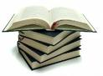

Book with More than Three Authors:
First Author in the List (Last Name, First Name), et al. Title of Book. City of Publication: Publisher, Copyright Date. Medium of Publication.
Example:
Bushey, Arthur, et al. Rocks and Fossils. San Francisco: Time-Life Books, 1996. Print.

Book with an editor(s) (when editor’s name is most significant):
Editor (Last Name, First Name) and First Name-Last Name, eds. Title of Book. City of Publication: Publisher, Copyright Date. Medium of Publication.
Example:
Miller, James E. and Robert O’Neal, eds. The United States in Literature. Oakland, NJ: Scott, Foresman and Company, 1981. Print.

Encyclopedia Article:
Author of Article. “Title of Section.” Encyclopedia Name. Year edition. Medium of Publication.
Example:
Barr, William. “Northwest Passage.” World Book Encyclopedia. 1998 edition. Print.

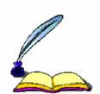

Government Publication:
Name of Government. Name of Agency. Title. Number of Publication. Place of Publication: Publisher, Date of Publication. Medium of Publication.
Example:
United States. Dept. of Labor. America’s Dynamic Workforce. Washington: US Dept. of Labor, 2004. Print.

Magazine Article with Consecutive Pages:
Author of Article. “Title of Article.” Magazine Title Date of Issue: Page Number(s). Medium of Publication.

Example:
Smith, Paul. “March Madness.” Sports Illustrated March 2001: 30-33. Print.

Magazine Article with Non-consecutive Pages:
Author of Article. “Title of Article.” Magazine Title Date of Issue: Initial page+. Medium of Publication.
Example:
Wood, Jason. “Spellbound.” Sight and Sound Dec. 2005: 28+. Print.

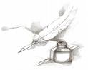
Newspaper Article:
Author of Article. “Title of Article.” Title of Newspaper [City of Publication if not in Title] Day Month Year of Publication, edition: page numbers. Medium of Publication.
Example:
Alaton, Salem. “So, Did They Live Happily Ever After?” Globe and Mail [Toronto] 27 Dec. 1997: D1+. Print.

Online Journal Articles from a Library Subscription Service such as SIRS:
Author. “Title of Article.” Title of Periodical Volume Date of Publication: Page Numbers. Title of Database.
Medium of Publication. Day Month Year of access.
Example:
Moyer, Patricia S. “Controlling Choice: Teachers, Students, and Manipulatives in Mathematics.” School Science and Mathematics Jan. 2004: 25-26. SIRS Researcher. Web. 12 Nov. 2008.
Example:
Giddins, Gary. “Davis, Miles.” World Book Online Reference Center. 2009. Web. 15 May 2009.

Personal Interview:
Name of Person Interviewed. Personal or Telephone Interview. Date interviewed.
Example:
Smith, Jane. Personal Interview. 9 Oct. 2001.

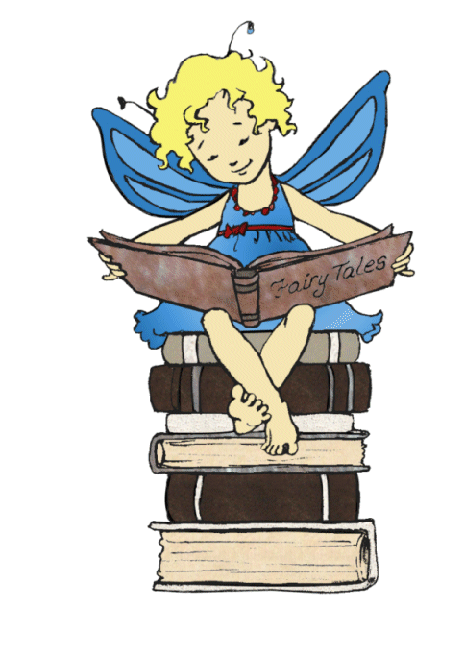
Published or Broadcast Interview:
Name of Person Interviewed. Interview, Type of Interview, or “Title of Interview if Given” by interviewer First Name Last Name. Title of Publication Publication Date: Page Numbers. Medium of Publication.
Example:
Hersch, Fred. Interview by Aaron Cohen. Down Beat April 2004: 20. Print.

Video Recording:
Title. Director. The Distributor or Publisher, original release date. Medium of Publication.
Example:
Shh! We’re Writing the Constitution. Dir. Jean Fritz. Scholastic,1990. Videotape.

Website:
Name of Author, Compiler, Editor, or Director. “Title of Page.” Title of Overall Website. Publisher of the site (if not available, use N.p.), Publication Date (if not available, use n.d.). Medium of Publication. Day Month Year of Access.

See specific website examples below:

Website Published by an Academic Institution:
Example:
Liu, Alan, ed. Home page. Voice of the Shuttle. Dept. of English, U of California, Santa Barbara, n.d. Web. 21 May 2009.

Website Published by an Individual:
Example:
Lessig, Lawrence. “Free Debates: More Republicans Call on RNC.” Lessig 2.0. N.p., 4 May 2007. Web. 15 May 2009.

Website Published by Corporate Author:
Example:
“Utah Mine Rescue Funeral.” CNN.com. Cable News Network, 21 August 2007. Web. 21 May 2009.



Yeargin 9
Works Cited
Banger, Edward and Bjorn Turoc, eds. “Heavy Metal Timeline.” Rock Docs. N.p., 2002. Web. 18 May 2009.
Baum, Adam. “Nuclear Weapon.” World Book Encyclopedia. 2006 edition. Print.
Burger, Hamilton, and Tom A. Toe. Fast Food America. New York: Franklin Watts, 2006. Print.
“Hourly New Summary.” National Public Radio. Natl. Public Radio, 20 July 2007. Web. 21 May 2009.
Hyde, Jacqueline. “Multiple Personality Disorder.” Current Health June 2008: 28-33. Student Resource Center. Web. 18 May 2009.
Ningmoon, Wayne, ed. “The Lunar Effect.” Cosmic Corridor. NASA, 29 July 2008. Web. 20 May 2009.
“Pesticide Contamination in Varied Pesticide-Use Settings.” Toxic Substances Hydrology Program. United States Geological Survey, 18 May 2009. Web. 20 May 2009.
Recksiek, Anna. The Truth About Eating Disorders. New York: Facts On File, 2005. Print.
Spellet, Howie, ed. UMCP Glossary. University of Maryland, College Park, May 2002. Web. 19 May 2009.

Heading is centered.

List is alphabet-
ized by first word in the citation. Not a bulleted or numbered list.

First line of each entry is at the left margin. Extra lines are indented ½”.

Double-spacing is used throughout.

My Resources


My Resources

Google Images: for all the great clip art and diagrams

Mr. Adam Yeargin: for his advice and contributions to my handbook in the form of the MLA citation information as well as the Works Cited list.

Ms. Tanya Johnson: for her advice and contributions to my handbook in the form of the BIG 6 information.



